i)Create a table named Bank with the following attributes
-bankcode (To be set as Primary Key, type= varchar(3))
-bankname (Should not be NULL)
-headoffice
-branches (Integer value greater than Zero)
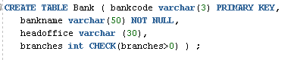
ii)Create a table named Branch with the following attribute
-branchid (To be set as PrimaryKey)
-branchname (Set Default value as ‘New Delhi’) –
bankid (Foreign Key:- Refers to bank code of Bank table)
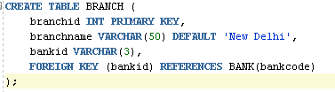
I) Create a View named bank_head office to hold the details of all bank whose head
office at Ernakulam.
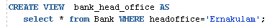
II) Create a View named bank_branch to hold the details of all bank who have branches
at kottayam.
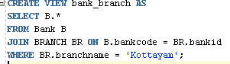
III) Create a View to show banks with more than 50 branches
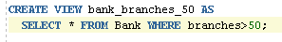
IV) Create a View to display bank name and branch name
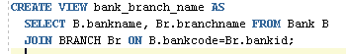
V) Create a View to show banks located outside Ernakulam

